**SAP HANA Live** (formerly SAP HANA Analytics Foundation or SHAF or SAP HANA ANALY) is solution for operational real-time reporting on HANA. HANA Live tries to bridge the gap of having operational reporting on top of OLTP system. Kind of to replace operational DWH as we know it. What you get once you install HANA LINE on top of SAP ECC/RRP is a suite of SQL views which spans across majority of ECC modules (FI, CO, MM, PP, SD, PS, CRM, GTS, AM and GRC).

They are SAP delivered SAP HANA calculation views for real-time operational of following categories.

A virtual data model consists of the following types of views:

**SAP HANA Live different Categories**

1. Query Views – for end users for their reporting needs. They are used for direct use in a HTML5 based Analytical application or to be used in an Analytical tool like BusinessObjects. Query views are normally not reused in other views and always remain on the top of hierarchy.

2. Re-use Views – for customers to have a kind of templates on which they can base their own query views. These views are the heart of virtual data models and are reused in other views. They are not designed to be directly used in other analytical tools - Business Objects

3. Private Views – encapsulate certain SQL transformations on one or several database tables or even other views. They are not classified as reuse views, as they might not carry clear business semantics, but are rather intended to be reused in other views. They are comparable to subroutines or (private) methods in programming languages. A private view may be based on database tables, other private views, or on reuse views

Currently there are 2000+ HANA virtual data model views

**The Technically deployment of SAP HANA Live involves**

1. Deployment of above-mentioned SQL views into your HANA system

2. Setting up SAP Landscape Transformation Replication Server to replicate data from ECC to HANA

3. Using BI client (SAP BO (e.g. SAP BO Dashboards, SAP BO Explorer, SAP BO Analysis edition for Microsoft Office, SAP Crystal Reports Enterprise), or SAP Lumira).

HANA Live Architecture

SAP HANA Live virtual data models are designed on the top of SAP Business suite tables. The data provided by virtual data models can be used using HTML5 based applications or with analytical tools like SAP BusinessObjects.

Following is the diagrammatic representation of the architecture of SAP HANA Live.

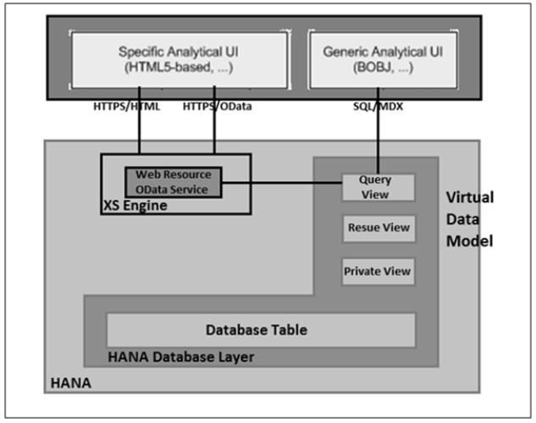

All reporting in SAP HANA Live is based on the underlying computing engine and on realtime data from SAP Business suite applications, hence there is no need to wait for data load.

In case, customers want to create new reports to enhance the existing ones, they just need to make changes to virtual data models or create new HANA models to support the report development quickly.

Technical System Landscape for SAP HANA Live

Following two approaches can be used for the deployment of SAP HANA Live on SAP Business suite.

Side by Side Scenario

In this scenario, you have two systems and data replications occur using SAP Landscape Transformation. To execute SAP HANA Live views, you need to replicate the corresponding tables in HANA database.

Integration Scenario

SAP HANA Live and Business Suite system shares the same SAP HANA appliance and this scenario is suitable for applications, which run directly on SAP HANA.